Instructions for the Registration to the Doctoral School of the SGGW
- Please create an account in Registration.
- It is required to complete the data in the "My Account" - Personal forms tabs.


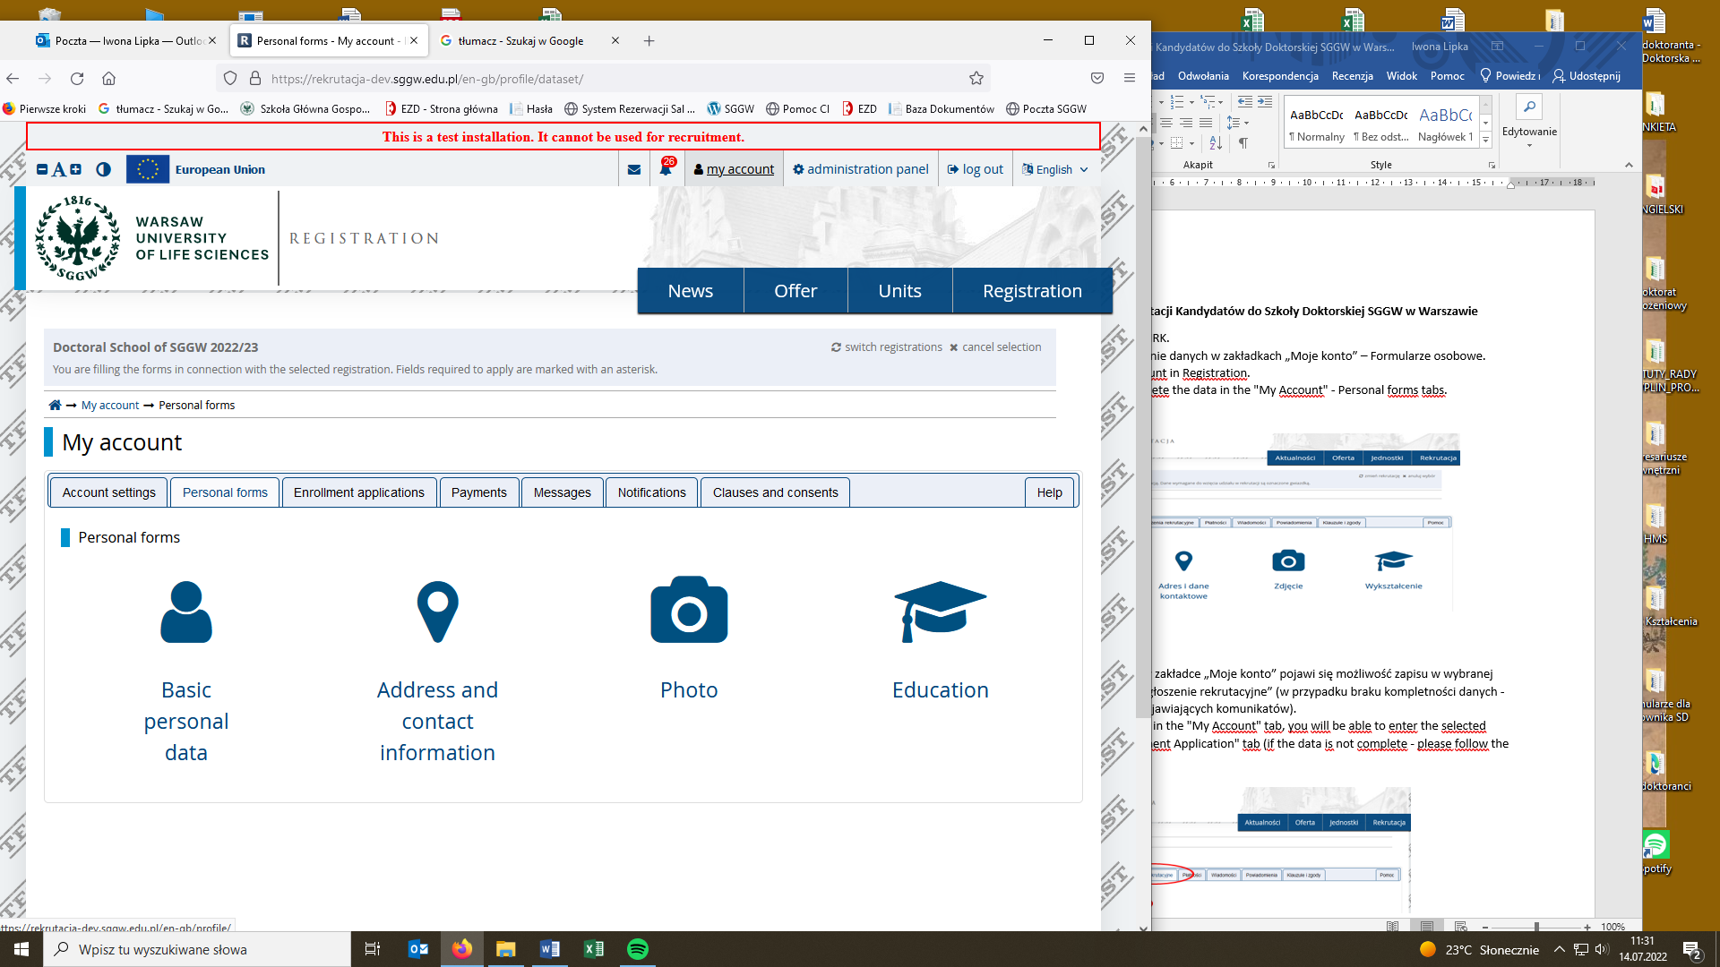

- After completing the data in the "My Account" tab, you will be able to enter the selected discipline in the "Enrollment Application" tab (if the data is not complete - please follow the messages that appear).

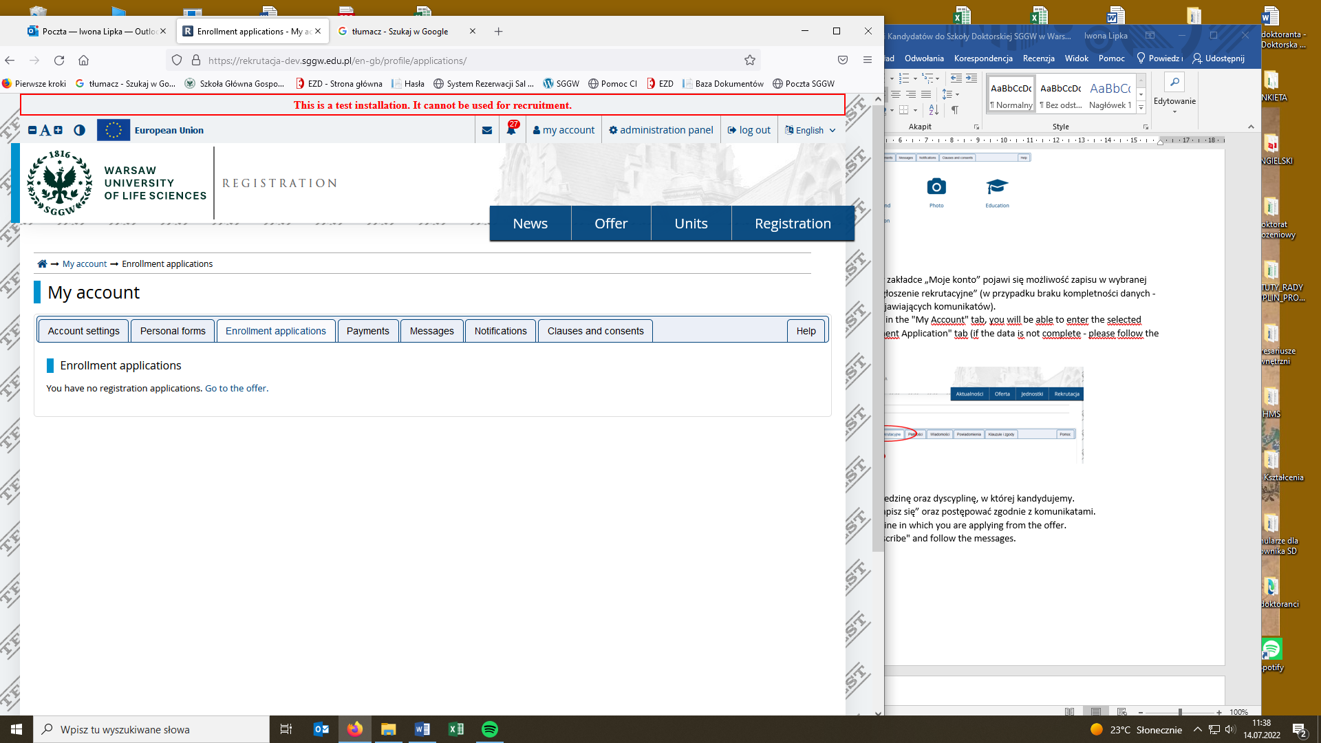

- Choose from the offer the field and the discipline in which you are applying.
- "Sign up" and follow the messages.


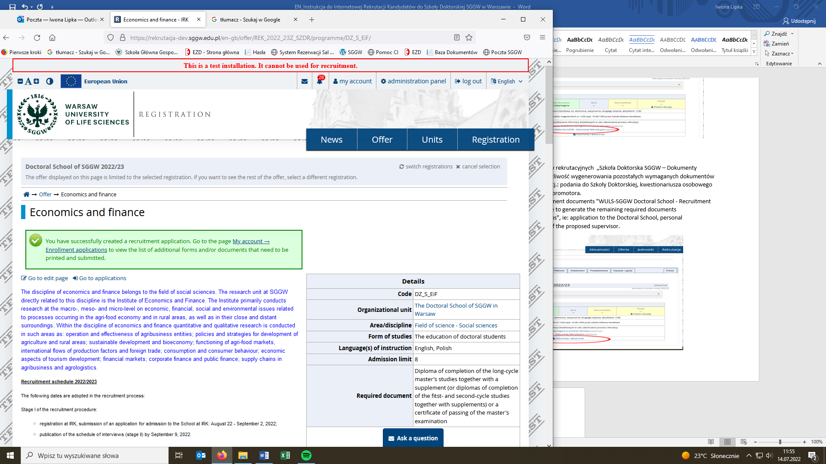
- The required recruitment documents "Doctoral School of SGGW - Recruitment Documents" should be attached.


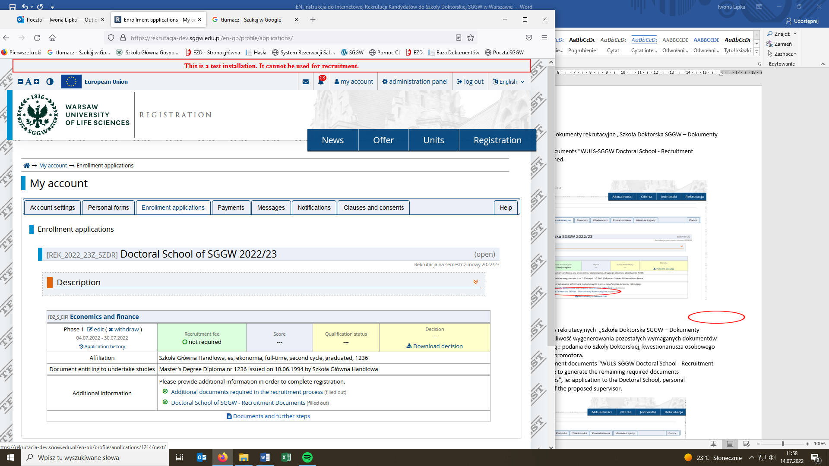

- After completing the recruitment documents " Doctoral School of SGGW - Recruitment Documents ", you will be able to generate the remaining required documents "Documents and further steps", ie: application form to the Doctoral School, personal questionnaire and consent of the proposed supervisor.

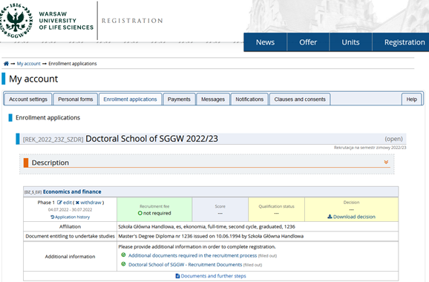

- The above-mentioned documents should be downloaded, printed, properly filled in, signed legibly (the application and the personal questionnaire are signed by the candidate, the consent form is signed by the proposed supervisor), scanned and uploaded to the file "Additional documents required in the recruitment process".

- Please pay attention to the messages and notifications appearing in the "My Account" recruitment account.

