logo | 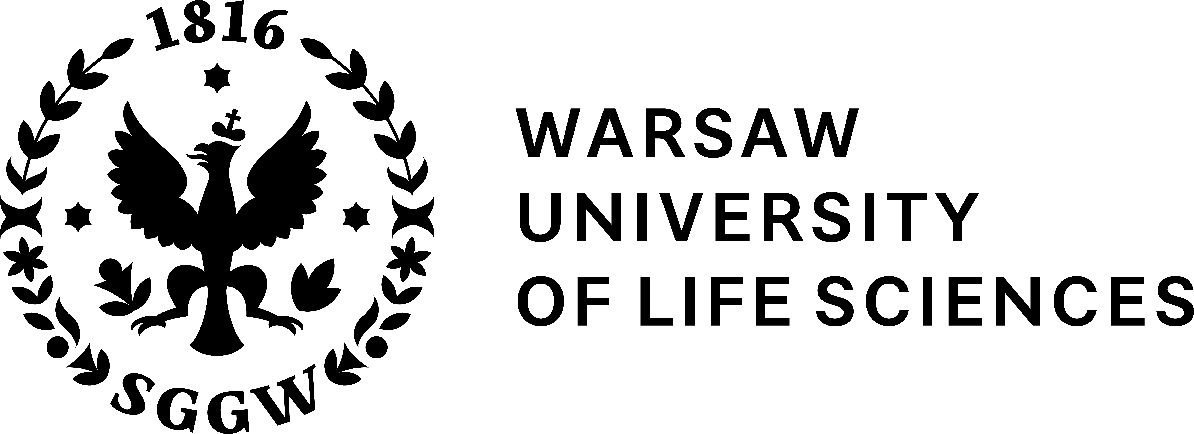

MEMORANDUM OF UNDERSTANDING

On scientific and educational cooperation
between
Warsaw University of Life Sciences – SGGW, Poland
and
XXXX

With the objective of promoting academic exchange and cooperation between the two institutions, they hereby agree to the following:

- Based upon the principles of respecting other’s independence and mutual benefit,
the two institutions agree to explore the possibilities of:

  - research in the fields of mutual interest
  - improvement of academic staff’s skills
  - exchange of academic staff and students
  - introducing new curricula
  - joint research projects
  - joint educational programs
  - exchange of publications and teaching materials

- In order to initiate any of the above mentioned activities, detailed working plans should be elaborated in the future that would result from mutual consultation and negotiations and would be signed by both institutions.

- This Memorandum shall impose no financial obligations of either institution. It is understood that financial arrangements will be negotiated in each specific case and will depend of the availability of funds. Each party agrees to seek financial resources for above mentioned activities. It is also understood that the details of joint activities will be negotiated for each specific case.

- The Memorandum is effective on the date of the signature hereto and will remain in effect for the initial period of 5 years. It can be extended for a period as mutually agreed by both parties. The Memorandum can be terminated by either institution by giving two months notice to the other party.

On behalf of On behalf of
XXXX Warsaw University of Life Sciences – SGGW

Prof. XXXX Prof. dr hab. Michał Zasada
Rector Rector

Date: Date:

