Instructions for the Registration to the Doctoral School of the SGGW
- Please create an account in Registration.
- It is required to complete the data in the "My Account" - Personal forms tabs.


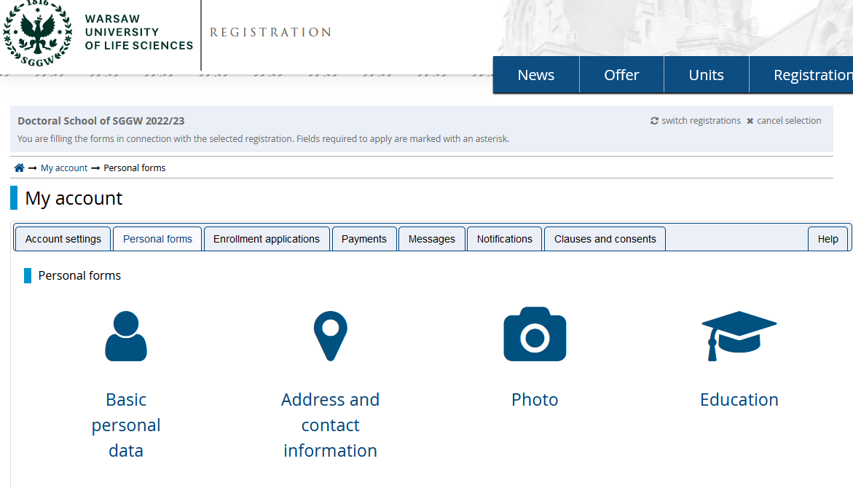

- After completing the data in the "My Account" tab, you will be able to enter the selected discipline in the "Enrollment Application" tab (if the data is not complete - please follow the messages that appear).

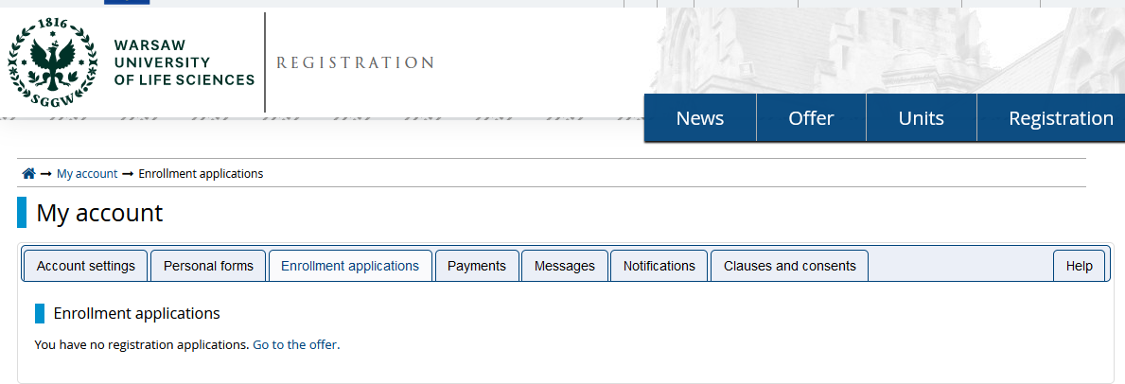

- Choose from the offer the field and the discipline in which you are applying.
- "Sign up" and follow the messages.


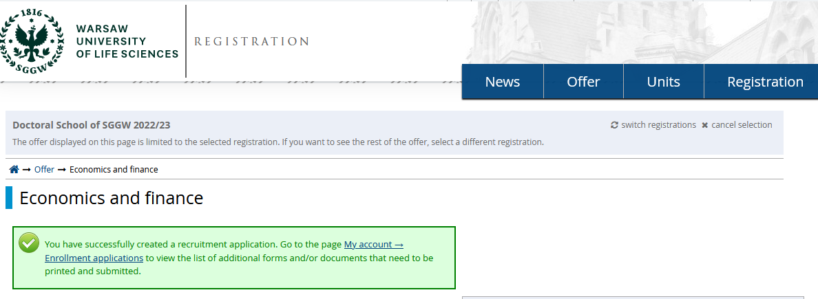
- The required recruitment documents "Doctoral School of SGGW - Recruitment Documents" should be attached.


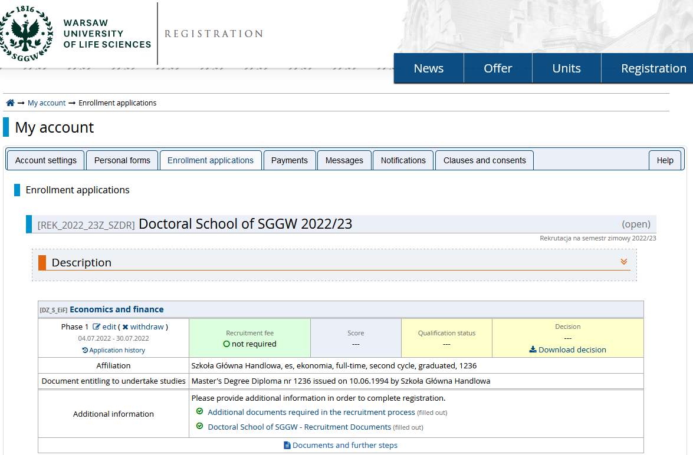

- After completing the recruitment documents " Doctoral School of SGGW - Recruitment Documents ", you will be able to generate the remaining required documents "Documents and further steps", ie: application form to the Doctoral School, personal questionnaire and consent of the proposed supervisor.

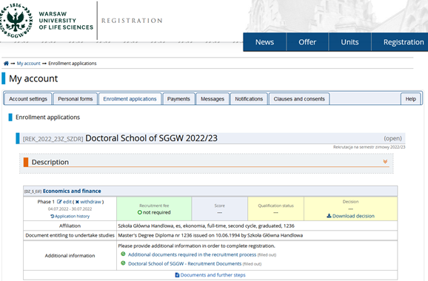

- The above-mentioned documents should be downloaded, printed, properly filled in, signed legibly (the application and the personal questionnaire are signed by the candidate, the consent form is signed by the proposed supervisor), scanned and uploaded to the file "Additional documents required in the recruitment process".

- The Doctoral School charges a fee for the recruitment process, which must be paid by August 11, 2024.
The amount of the recruitment fee for the Doctoral School in the academic year 2024/2025 is:
- PLN 300 if the payment is made to an account in PLN
(account number for PLN deposits - 68 1240 6003 1111 0011 3480 4676)

- or EUR 80 if the payment is made to an account in EUR
(account number for EUR deposits - 73 1240 6003 1978 0011 3480 4692)

- Please pay attention to the messages and notifications appearing in the "My Account" recruitment account.

